3G611R (3G611R+)-How to limit the computer in the LAN to access some websites by URL filtering？
Product line: 3G Question category: Function configurations

Q：Why we need to configure the URL Filtering?
A：In order to control the computer has access to websites. You can use URL Filtering to allow the computer to access to certain websites at fixed time or forbids it having access to certain websites at fixed time.

The topology is as below
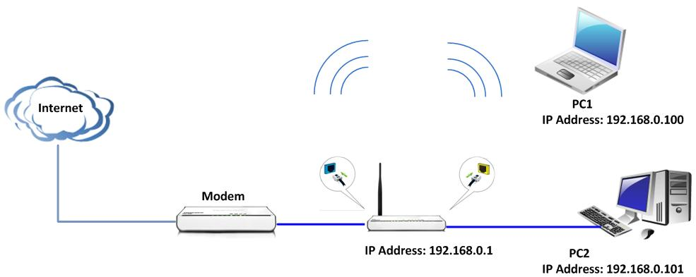
Steps are as following:
- Login the management page of the router.
- Click the Security Settings→URL Filter on the left of the page.
Tick Enable for the URL Filtering Settings
For example, you want to prevent the computer whose IP Address is 192.168.0.100 to access the websites that include “Google” from 8:00 am to 18:00 pm every day. And the computer with other IP Address can access the website. You can set the router following the picture as below.
